ZEE MUSIC REQUIREMENT ANALYSIS
Dashboard-1
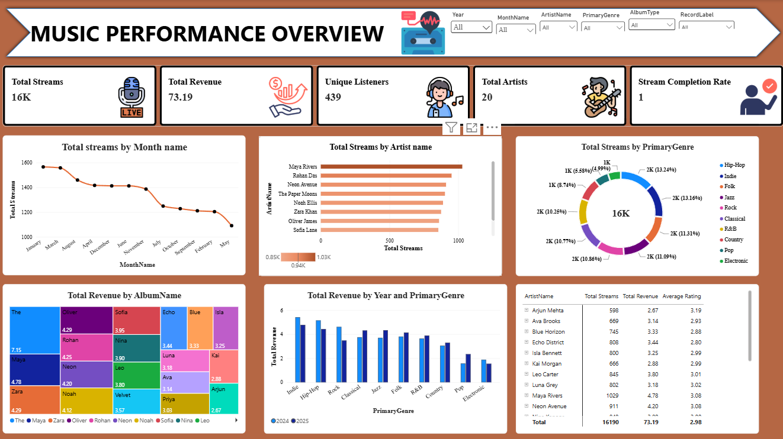

Dashboard-2


